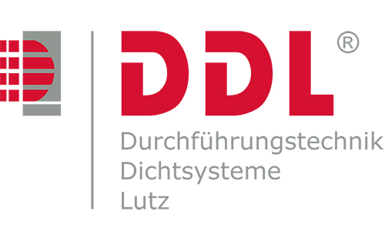
Tender specification text
Wall sleeves

Fiber cement

Wall sleeve made of asbestos-free fiber cement for the installation of annular seals

Wall sleeve with smooth internal wall and closed circular grooves on the external wall
to be delivered and – according to the indications on the drawing – installed flush within the shuttering during the structuring work (before pouring the concrete) and secured against dislocation.

Product:
DDL Wall Sleeve fiber cement
DDL GmbH, 73249 Wernau / N.
or equivalent

Inside diameter of the wall sleeve: DN/ID ….…..…...… mm

Installation length of the wall sleeve: L ….….…....… mm

Material: Asbestos-free fiber cement

Model/Name: Fiber cement DN…….…..…

Amount of wall sleeves: Pcs. ………..…………..

Unit price: ……………€ Total price: ………………..€

